



EPON ONT

1 GE Port

EU201-G

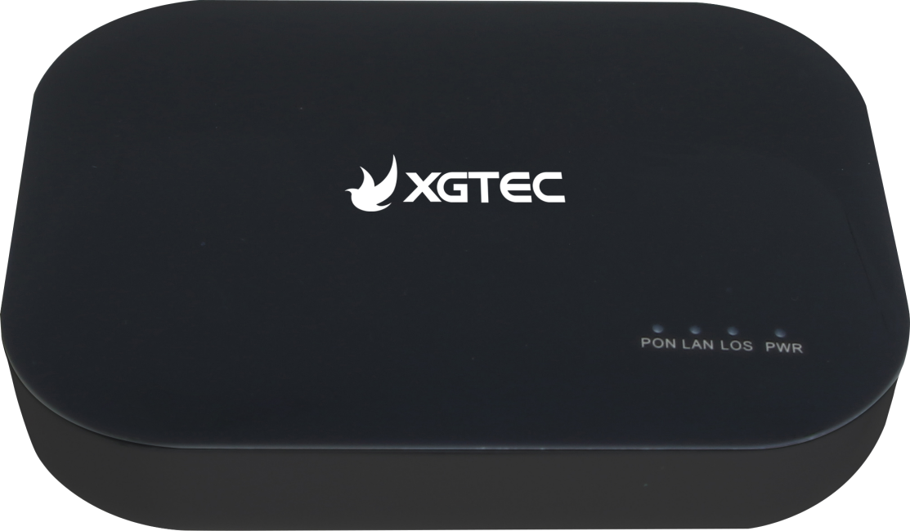

Characteristics

* Plug and play,integrate auto detection,auto configuration and auto firmware upgrading.
* Support diagnostic monitoring and remote disabling of fiber optical.
* Full speed 1G non-blocking switching.
* 2048 MAC address.
* Fiber access and gigabit port provide incredibly fast transfer speeds.
* Integrated port monitoring,port mirroring, port rate limiting,port SLA, etc.
* Support auto polarity detection of Ethernet ports (AUTO MDIX).
* Integrated IEEE802.1p QoS with four level priority queues.
* Supports mixed network with mainstream OLT to minimize operators' network construction costs.
* With the industry's most advanced technology,it has powerful functions and QoS guarantees in Ethernet services.
* Desktop devices take up less space and consume less power.

Specification

|  |  |
| --- | --- |
| Protocol Standards | IEEE802.3ah |
| Dimension | 105*76.5*26.5mm(length*width*height) |
| Fiber port | 1 EPON interface,SC/PC single-mode/single-fiber  Upstream rate 1.25Gbps  Downstream rate 1.25Gbps |
| Wavelength | Tx 1310nm,Rx 1490nm |
| Fiber interface | SC/PC |
| PON TX Power | 1~3dBm（1310nm） |
| PON RX sensitivity | <-27dBm（1490nm） |
| Power | ≤ 3W |
| LAN | 1*10/100/1000Mbps adaptive Ethernet port,full/half duplex,RJ45 interface |
| Throughput | Throughput can reach 900Mbps or more |
| Button | Reset,Power |
| Power Supply | DC 12V 0.5A |
| Operation | Working temperature: -10°C~50°C  working humidity:10%~90%  (non-condensation) |
| Storage | Storage temperature: -30°C~60°C storage humidity: 5%〜95％ (non-condensation) |

Application

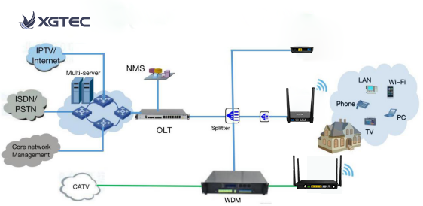

Shenzhen XGTEC Technology Co.,Ltd.

Web: www.xgtecpon.com E-mail: [sales@xgtecpon.com](mailto:sales@xgtecpon.com)

Address:No.702, Building D1,TCL International E City,No.1001,Zhongshanyuan Road,Xili Street,Shuguang Community,Nanshan District,Shenzhen,P.R China.